[reflexion-plan-acción.docx](https://uv.utecvirtual.edu.sv/salonv/pluginfile.php?file=%2F403386%2Fmod_resource%2Fcontent%2F2%2Freflexion-plan-acci%C3%B3n.docx)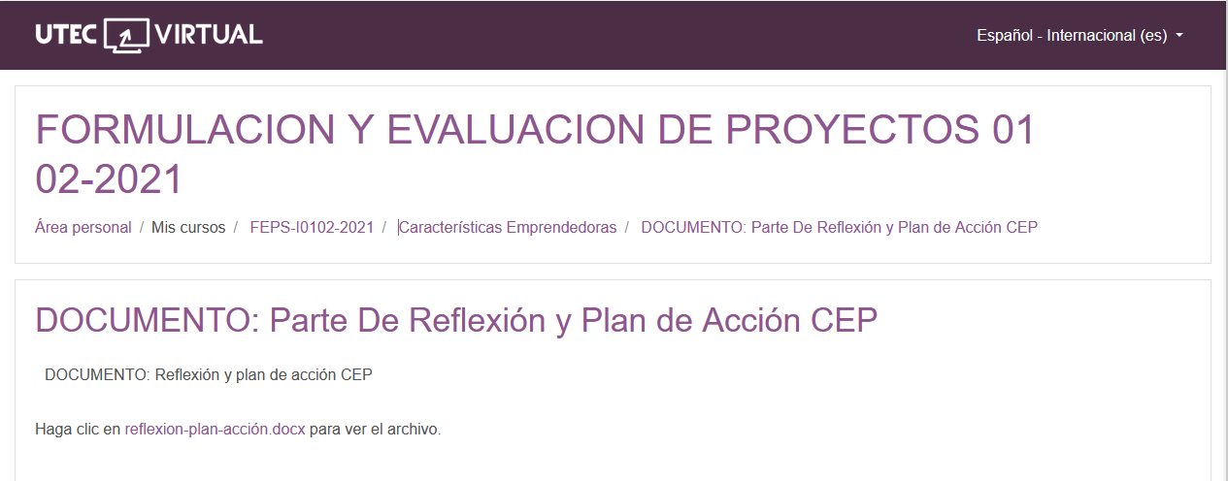

<https://uv.utecvirtual.edu.sv/salonv/pluginfile.php?file=%2F403386%2Fmod_resource%2Fcontent%2F2%2Freflexion-plan-acci%C3%B3n.docx>